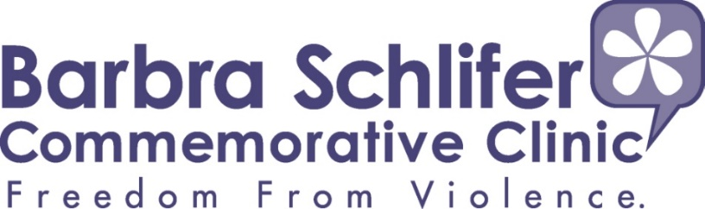

Job Posting
Transitional & Housing Support Program Counsellor
One year Full-Time Contract

Barbra Schlifer Commemorative Clinic offers trauma-informed Legal services and representation, counselling, and multilingual interpretation, and drives system transformation to support women and gender diverse people who have experienced violence. Rooted in the foundations of intersectionality, innovation, and a client-centered approach, we foster the skills and resilience of the people we serve and amplify their voices to create individual and collective change.

The Clinic’s Counselling Department is seeking a full-time Transitional and Housing Support Program Counsellor for a 12-month contract.

DUTIES AND RESPONSIBILITIES

All duties and responsibilities will be carried out in accordance with Barbra Schlifer Clinic's Mandate, Mission and Values Statements.

CLIENT SUPPORT:

- Assess client needs and complete risk assessments and safety planning with clients.
- Develop plans and set housing-related goals with clients.
- Assist clients in completing applications under the Special Priority Program (SPP) for survivors of domestic violence and human trafficking.
- Assist clients in accessing housing and income support, including Access to Housing, Ontario Works, and the Ontario Disability Support Program (ODSP).
- Support clients with identifying suitable and safe housing locations and connect them with resources to support their transition and adjustment to new communities.
- Facilitate Housing Information sessions and co-facilitate counselling support groups.
- Provide information and guidance to help clients navigate social services.
- Provide emotional support and crisis intervention to clients using trauma informed and client centered approach.
- Build and maintain relevant external partnerships to support clients’ housing stability.

AGENCY AND TEAM SUPPORT:
- Participate on agency committees and contribute to events, including clinical meetings and staff meetings.
- Communicate with team members to share critical information in a timely manner and work to resolve issues effectively and efficiently.
- Represent the Clinic at relevant committees/networks and share information and updates as needed.
- Utilize an anti-oppressive approach when working with clients and colleagues.

ASSESSMENT AND REFERRAL:
- Assess client needs and advocate on behalf of clients by providing support, information, and warm referrals.
- Conduct research to identify appropriate services for clients.
- Consult and collaborate with other departments as needed to meet client needs.
- Prioritize calls based on safety, date received and crisis situations

ADMINISTRATION & OTHER:

- Document client notes and statistics in the client management system, EMHware.
- Prepare support letters and service confirmation letters for clients in consultation with the Director of Counselling/Program Manager.
- Complete and submit monthly timesheets and other reports as required.
- Comply with Clinic and funder policies and procedures
- Perform other tasks as assigned by management.
MINIMUM QUALIFICATIONS:
- Degree or diploma in a field related to counselling (BSW, SSW, MSW).
- Minimum of two years’ experience delivering transitional and housing support to survivors of gender-based violence using a trauma-informed approach.
- Experience with risk assessment, and safety planning, and thorough knowledge of social service and social welfare systems.
- Experience providing information and referrals specific to the needs of women and gender-diverse people fleeing violence.
- An understanding of the issues and dynamics related to providing transitional and housing support services to women and gender-diverse people who have experienced interpersonal violence, consistent with a trauma-informed, feminist, anti-racist, and anti-oppressive analysis.
- Experience working with human trafficking survivors.
- Strong advocacy skills.
- Experience working in a diverse work setting and with a diverse client population.
- Intermediate computer skills.
- Excellent administrative and letter-writing skills.
- Excellent communication and conflict-management skills.
- Fluency in a second language is considered an asset.

CORE COMPETENCIES:
- Commitment to work collaboratively with and supporting clients from diverse backgrounds within a diverse agency.
- Engagement in self-reflective, ethical, and collaborative practice that is non-judgmental and empathetic, reflecting the vision and mission statements of the Clinic.
- Incorporation of the principles of diversity and equity in responding to the service needs of women
- Commitment to removing systemic barriers to women’s independence and wellbeing.
- Excellent interpersonal, organizational, time-management, problem-solving, written, and oral communication skills.
- Ability to work independently and as part of a team in a multidisciplinary environment.
- Ability to be a self-starter, creative, and highly motivated.
- Ability to share ideas and differences in the spirit of collaboration and cooperation.
- Commitment to ongoing personal and professional development.
- Ability to work and support others in the context of a diverse environment

SALARY: $53,251 per annum. The position includes a comprehensive benefits package offered through a group plan as part of our United Way membership, upon satisfactory completion of probationary period.

DEADLINE: November 30, 2026. Job posting will remain open until a suitable candidate is engaged

DURATION: One year FT (35 hours/week)

APPLICATION: Submit your cover letter and resume in ONE attachment to: hr@schliferclinic.com with the subject line of Transitional and Housing Support Program Counsellor. In your cover letter, please indicate where you found our job posting.

Barbra Schlifer Commemorative Clinic is an equal opportunity employer that welcomes candidates from equity-seeking groups and is committed to providing accommodation for people with accessibility needs. Please let us know if you require accommodation due to an accessibility need during any aspect of the recruitment process, and we will work with you to address your needs.

We thank all candidates for their interest. However, only those applicants selected for an interview will be contacted. NO PHONE CALLS PLEASE

